Title
Authors | 1st |  | 2nd |  | 3rd |  |  |  | 4th |  | 5th
Category | Field of the paper |  |  |  |  |  | Session
 | Management of Technology |  |  |  |  |  | General Paper  Presentation
 | Science and Technology Economics and Policies |  |  |  |  |  | Masters Degree Candidate colloquium
 | Theory of Technological Innovation |  |  |  |  |  | PhD Candidate  colloquium
Language of the paper | Korean ( ) English ( ) Session in English ( )
Speaker | Name |  |  |  |  | Affiliation
 | email |  |  |  |  | Cell phone
Corresponding  Author | Name |  |  |  |  | Affiliation
 | email |  |  |  |  | Cell phone
Date of submission

The Applicants (all authors) must be members of KOSIME to present. For the signing-up for the membership, please contact sime@daum.net 02)877-2310

Title

Authors....

Abstract

Abcd efg
Cefg

keywords: green innovation, …

I. Introduction

Green Innovation…

Green Innovation…

II. B

2.1 CDE

2.1.1. EFG

Green Innovation…

Green Innovation…

<Table 1> ?????

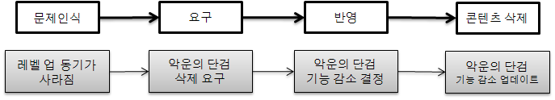
<Figure 1> ??????

<References>

(1) Korean

1. 김경영‧박기술(2009), “기업 R&D 투자에 대한 정부지원정책 효과 분석,” 「기술혁신연구」, 제31권, 제3호, pp.34-45.

(2) English

2. Knight, G.(1997), "Cross-cultural Reliability and Validity of a Scale to Measure Firm Entrepreneurial Orientation, Journal of Business Venturing, Vol.12, No.2, pp.213-225.

affiliation (email)

